**ASSIGNMENT 6**

**BIND AND REVERSE PAYLOADS, MAINTAINING ACCESS AND BACKDOORS**

# **INDEX**

|  |  |  |
| --- | --- | --- |
| **SL NO** | **TOPIC** | **PAGE NO** |
| 1. | Creation of Payloads for Windows | 2-3 |
| 2. | Report on today’s lecture | 4 |

# **Topic: BIND AND REVERSE PAYLOADS, MAINTAINING ACCESS AND BACKDOORS**

ASSIGNMENT 6(DAY 6) Date:02-07-2022

1. **Creation of Payload for Windows**

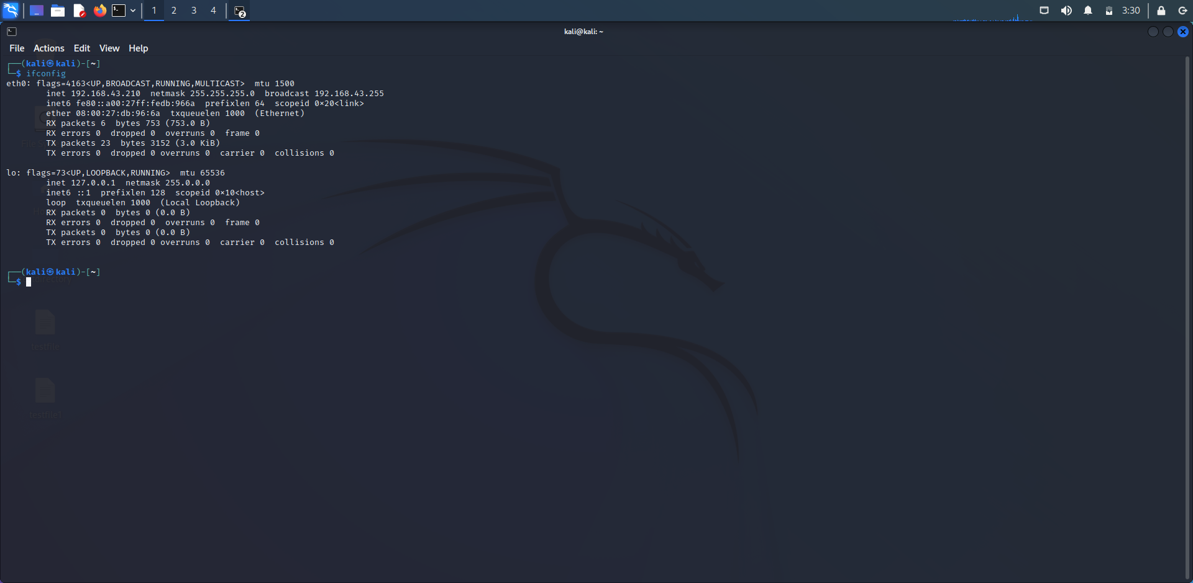

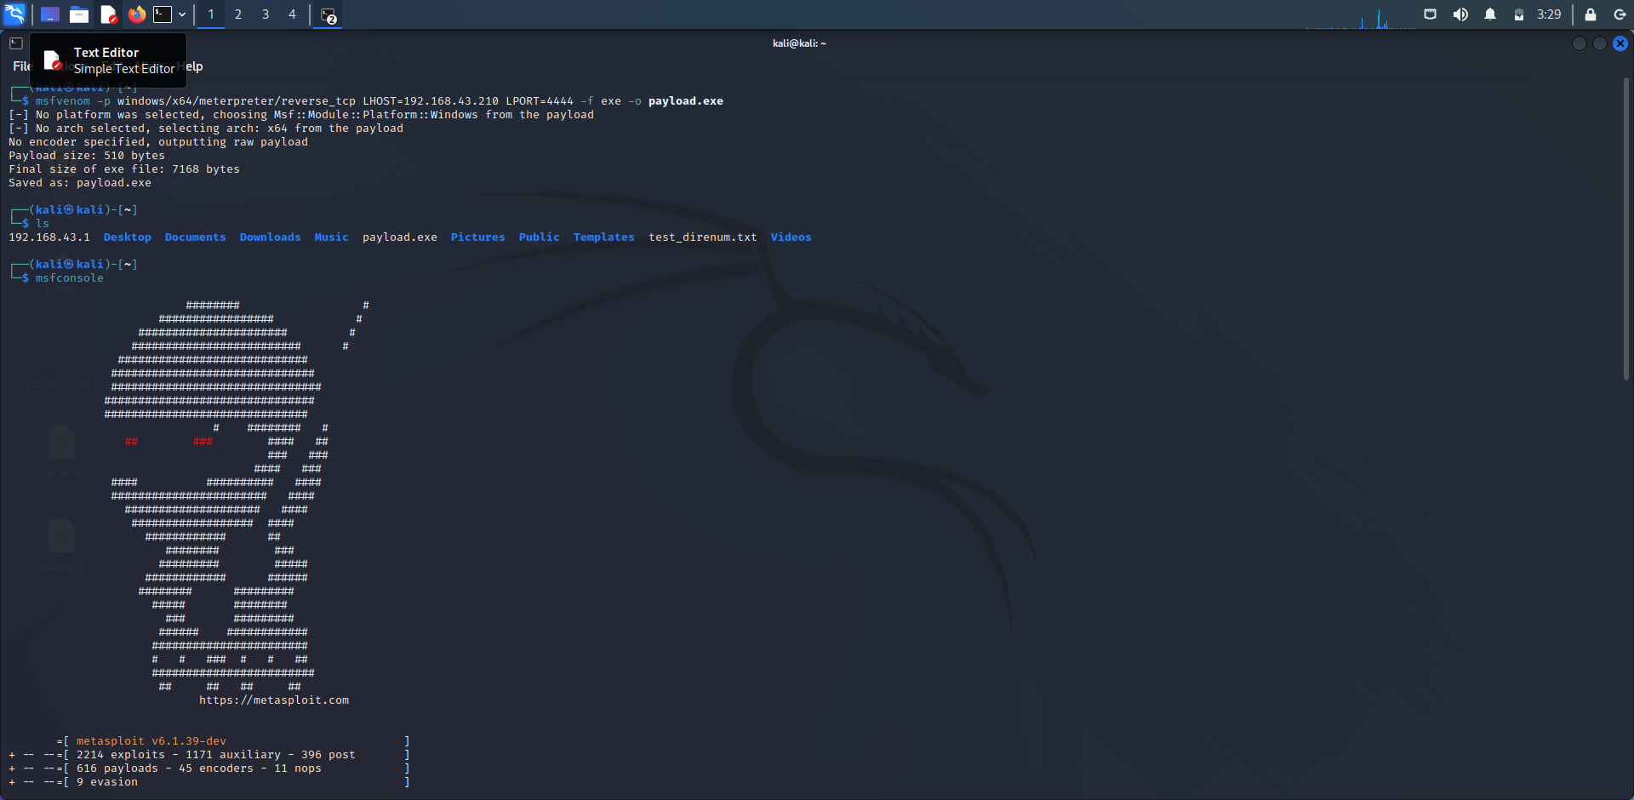

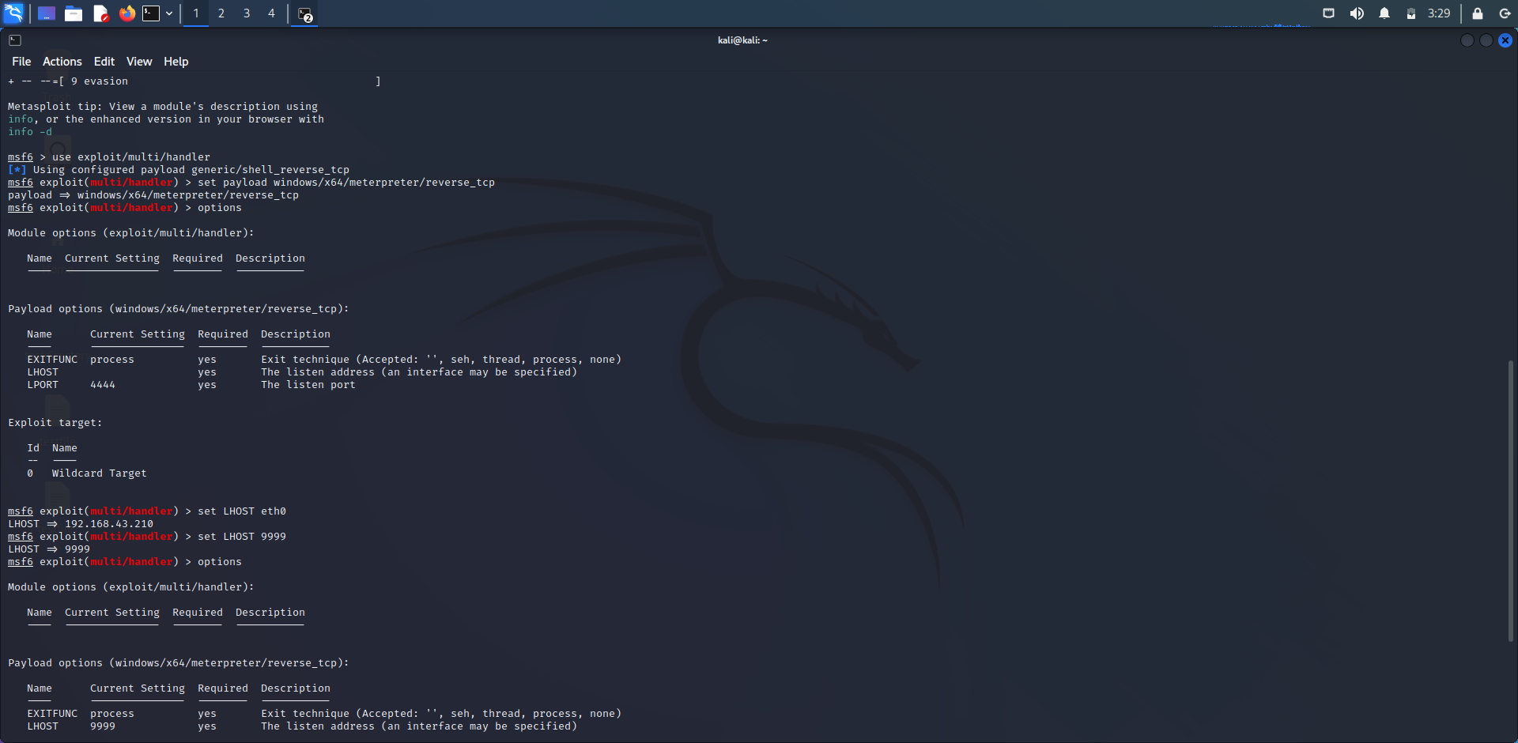

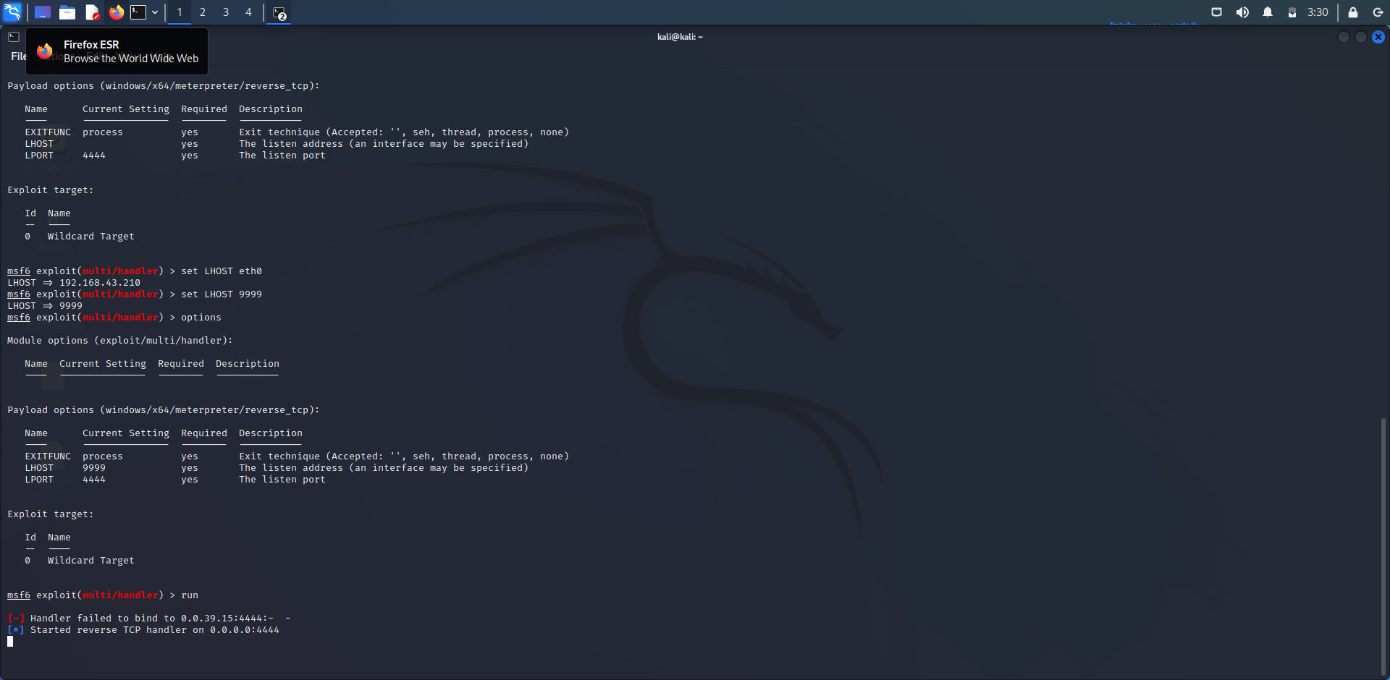

**2.Summary Report of today’s lecture.**

* **What are payloads:**
* **They are parts of cyber-attacks which cause harm.**
* **What payloads can do?**
  + **Data theft, deleting or modifying files.**
* **The process of execution for payloads.**
* **What are bind payloads?**
* **It is a type of shell in which the target machine opens up a communication part or a listener on the victim machine and waits for incoming connection.**
* **What are reverse payloads?**
* **They are the type of shells that remove the need for a listener on the target machine, which means we don’t have to leave the target vulnerable to other malicious actors.**
* **Difference between bind and reverse payloads.**
* **What is maintaining access?**
* **Tools for maintaining access.**
* **What are covert channels?**
* **A covert channel is when data is being sent through secret communication tunnels.**
* **What is a backdoor.**
* **How backdoor works. Its detection and prevention.**

**NAME: 20BCEA56**

**SIC: 20BCEA56**

**BRANCH: CEN**